Nagalaxmi Sama 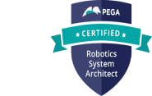 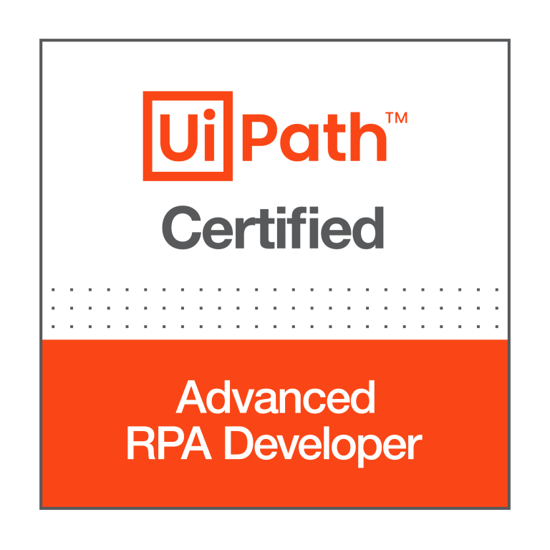
Ph: 302-525-1072 Email: laxmisnl917@gmail.com
Professional Summary:
- 9+ years of experience in IT industry with expertise in Financial and Supply chain domains.
- Expertise in developing and deploying unattended and attended bots in UiPath and Pega Robotics.
- UiPath Certified Advanced RPA Developer v1.0 (UiARD).
- Have good experience in interacting with various applications such as Web based applications, Excel, PDF, Text files, Slack, Google Drive, Google Spread Sheets, SAP, Integration Services, Amazon S3 Storage Buckets and APIs using UiPath.
- Well versed with UiPath Studio, UiPath Assistant, UiPath Orchestrator, Document Understanding, AI/ML.
- Expertise in exception handling and troubleshooting bots in UiPath.
- Hands on experience in working with RE Framework, UiPath Orchestrator Assets, Libraries, Processes, Queues, Packages, Jobs, Triggers, Integration Services.
- Worked on bot deployment into different environments i.e., DEV, SIT, UAT and Prod.
- Hands on experience invoking other language codes from UiPath such as C# and Python.
- Hands on experience in working with Reporting tools such as Kibana and Tableau.
- Interacted with Microsoft Excel, Outlook and text files using Pega Robotics studio.
- Hands on experience in working with Reporting tools such as Splunk (using Pega robotics)
- Good experience in interacting with MongoDB, PostgreSQL using Python language and automated various tasks using different Python libraries.
- Good experience in SQL, NoSQL (MongoDB), PostgreSQL and shell scripting, C#, VB.NET.
- Good Knowledge of HTML, CSS & JavaScript.
- Hands on experience in working in Agile methodologies Scrum and Kanban.
- Hands on experience in working on version control tools like bitbucket, git.
- Worked on multiple POCs to assess automation feasibility for business processes.
- Worked on preparing Process Definition Documents (PDD) and Solution Design Documents (SDD).
- Mentoring new team members and providing training/KT to freshers.
Technical Skills:
RPA Tools: Pega Robotics Studio (Open Span) 8.0, 7.1V, UiPath Studio, Orchestrator, UiPath Assistant, Document Understanding, Automation Anywhere.
Databases: MS SQL Server, PostgreSQL, MongoDB (NoSQL)
Cloud: AWS
Data Visualization Tools: Tableau, Kibana, Splunk, Looker
Languages: C#, Python, HTML, CSS, JavaScript
Operating System: Linux, Unix, Windows
Version Control: Git, Bitbucket
IDEs: Visual Studio Code, Spyder

Professional Experience:
Peloton Remote
Sr. Automation Engineer Oct 2023 – Present
Working as a Sr. Automation Engineer and am involved in designing, developing and deploying various bots using UiPath and Automation Anywhere. Below are my responsibilities:

Responsibilities:
- Worked with business partners on identifying new automation opportunities to reduce the manual effort, errors in the manual process and time consumption.
- Creating PDD documents and design documentations (SDD) as per the requirements of automation and review with Business.
- Worked on multiple automations which supports various departments across Peloton such as HR, Supply Chain, Reverse Logistics and Apparel team.
- Created process flow diagrams using Lucid chart and Miro.
- Developing logical automations as per the process requirement and perform unit testing of the bots and provide demonstration to the business to get a signoff request for production Release.
- Hands on experience in creating shared libraries to build reusable components in UiPath.
- Worked on JSON serialization and deserialization while utilizing API services.
- Interacted with various applications from UiPath such as different Web based applications, Excel, Google Drive, Google Spreadsheets, Slack, AWS S3 buckets and JIRA.
- Built an end-to-end UiPath solution for invoice reconciliation between Salesforce and ERP application, including data extraction, comparison logic, exception handling, and reporting.
- Created automation tasks to fetch and manipulate data in Google spreadsheets using Python.
- Hands on experience in migration bots from UiPath to Automation Anywhere.
- Analyzed bot runs and prepared key performance indicators to improve performance.
- Using GitHub for version management of bot solutions.
- Involved in Code review process.
- Following Agile scrum methodology and acted as a Scrum Master for our daily scrum meetings.

Bank of America Hyderabad, India
Software Engineer II B Nov 2021 – June 2023

Worked as a Sr. RPA developer in developing and deploying various bots for multiple LOBs involving different applications using UiPath tool. Below are my responsibilities in overall bot development process:

Responsibilities:
- Worked closely with Business users in identifying and analyzing the requirements.
- Creating the design documents after understanding the use cases and the current system.
- Involved in Analysis, Estimation, Module Design, and Preparing Solution Design Documents and Unit Testing
- Interacted with various applications from UiPath such as Web applications, Excel, CSV, Word, PDFs, API services and SharePoint.
- Hands on experience using C#.NET to build custom code in UiPath.
- Worked on additional log parameters for better filter criteria from Kibana.
- Prepared Visualizations and Kibana Dashboards as per client requirement.
- Worked on development of backend UI services in Python which interacts with MongoDB and performs various operations such as reading data from multiple mongo DB (NoSQL database) collections by applying filters and updating documents in the collections and manipulating data.
- Worked on unit testing API services from Insomnia.
- Worked on various tasks that reduce manual effort using Python and UiPath.
- Developed dashboards in Tableau for monitoring Machine Learning model performance.

Accenture Hyderabad, India
RPA Developer June 2019 – Nov 2021

Responsibilities:
- Worked as an RPA Developer and I have developed and successfully deployed various bots using UiPath and Pega Robotics tools.
- Hands on experience in migration of bots from Pega Robotics Platform to UiPath.
- Creating the design documents after understanding the use cases.
- Involved in Analysis, Estimation, Module Design, and Preparing Solution Design Documents and Unit Testing
- Designing automated process solutions in accordance with the standard RPA design principles and conventions and performed unit testing.
- Involved in status calls daily to update the status of development.
- Followed Agile scrum methodology and was involved in all scrum ceremonies.
- Followed best practices while developing bots.
- Prepared Visualizations and Kibana Dashboards as per client requirement.
- Worked with QA team to review the test scripts prepared by the team.
- Supported bot testing during the UAT phase and while deploying the bot in Production.
Tech Mahindra Hyderabad, India
Software Engineer May 2016 – June 2019

Responsibilities:
- Worked as an RPA Developer and I have developed and successfully deployed various bots using Pega Robotics.
- Interacted with various applications such as Windows, Web, and Excel files for developing attended bots through Pega Robotics studio.
- Developed logical automations as per the process requirement and performed unit testing.
- Worked on Plant configuration bot to integrate with SAP windows application.
- Worked on multiple bots by interacting with Web adapters.
- Involved in daily scrum calls to update the status or progress of development activities.
- Monitoring health check of bots and debugging the exception scenarios.
- Worked on explicit logging mechanism to store exception messages.

Education:
Bachelor of Technology in Electronics and Communication Engineering: JNTUH, Telangana, India
Certifications:
Pega CRSA v8.0
UiPath Certified Advanced RPA Developer (UiARD)

