**HIRA SHOUKAT**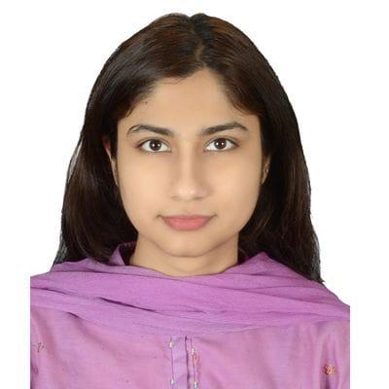

**(+92) 336-6598082|** [**hirashoukat60@gmail.com**](mailto:hirashoukat60@gmail.com) **| Faisalabad, Pakistan |** [**linkedin.com/in/hirashoukat60**](https://www.linkedin.com/in/hirashoukat60)

**English Teacher |Writer | Novelist |editor**

Creative Writing | Artistic Skills | Cultural Competence | Creativity & Research | Adaptive Learning

* English Literature & Language graduate with a TEFL certification and a strong passion for teaching and storytelling.
* Currently teaching English to **intermediate-level students**, with a focus on language skills, critical thinking, and cultural awareness.
* Experienced in high-performing, fast-paced academic environments, using innovative teaching methodologies and educational technologies.
* Published author and poet with multiple original works across genres, featured on global e-reading platforms with thousands of reads.
* Skilled in creating engaging content, building vivid characters, and exploring cultural themes through fiction and poetry.
* Actively participates in workshops, training sessions, and conferences to stay updated with modern teaching practices and language trends.
* Committed to fostering cross-cultural communication and supporting learners in using English effectively in diverse contexts.

**CORE COMPETENCIES**

| * Creative Writing * Character Development * Storytelling * Technical Proficiency * Cultural Sensitivity * Record Keeping | * Research & Documentation * Editing & Proofreading * Project Management * Classroom Management * Professional Development * Cultural & Language Workshops | * Engagement & Feedback * Sales & Royalties * Curriculum Development * Individualized Instruction * Student Assessments * Program Development |
| --- | --- | --- |

**PROFESSIONAL EXPERIENCE**

**RTI (Regional Training Institute), Faisalabad, Pakistan 2021 – Present**

**English Instructor**

Taught the English subject to intermediate-level students enrolled in the Family Welfare Worker (FWW) diploma program. Designed and delivered tailored lessons, created assessments, and provided feedback to support language development. Adapted teaching methods to suit various learning styles and maintained effective classroom management in a structured academic environment.

**Contracted Author | Cloudary Holdings (WebNovel), Singapore New Reading Technology PTE LTD. (GoodNovel), ByteDance (Fizzo, MyTopia)**

Develop compelling, original content from concept to completion, with a focus on storytelling, character development, and world-building. Conduct in-depth research to ensure accuracy in themes, settings, and cultural contexts. Edit and proofread manuscripts to uphold high standards of quality. Manage deadlines effectively for timely delivery of chapters and books. Engage readers by responding to feedback and building a loyal fan base across global platforms. Negotiate publishing contracts, monitor royalties, and implement strategies to maximize revenue.

AMAL Academy, Lahore, Pakistan 2019 – 2020

**Career-Prep Fellow**

Served in an education startup funded by Stanford University to teach professional skills to students and corporations.

* Chosen from more than 4.5K applicants for intensive three-month Fellowship funded by Stanford University.
* Invested over 150 hours to develop business skills, including communication, leadership, problem-resolution, and teamwork, among others.

**EDUCATION**

**Master in Applied Linguistics |** Government College Women University Faisalabad, Faisalabad, Pakistan (2024-2026)

**Bachelor of English Literature |** Government College Women University Faisalabad, Faisalabad, Pakistan (2020) • CGPA: **3.29**

**CERTIFICATIONS**

Freelancing • Digi Skills Training Program (2019) | Creative Writing • Digi Skills Training Program (2019)

TEFL 120 Hours (teaching English as a Foreign Language) (2023) • ESL (English as Second Language) 2023

Certificate of Achievement • INKSPELL All Pakistan English creative writing competition (2020)

**Publications**

Shoukat, H. (2025). *When words fail, memes speak: The weird and wonderful ways of expressing emotions*. *Annual Methodological Archive Research Review*, *3*(5), 1–25. <https://doi.org/10.63075/adh10098>

**CONFERENCES & SEMINARS**

Two-day Symposium on Postcolonial Literature (2019)

Seminar on Cultivating Leadership Capacity in Youth (2019)

**LANGUAGES**

English (Full Professional Proficiency)

Urdu (Native/Bilingual)

Punjabi (Native/Bilingual)