 |  | 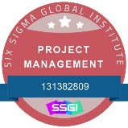 | 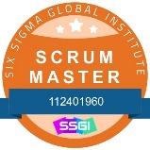 | 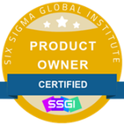 | 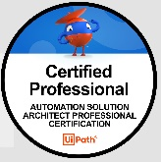 | 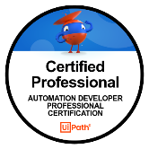

APEKSHA SAHU
RPA Architect and Manager
Email: emailapeksha2025@gmail.com Phone: (720)-731-6541

PROFILE  • Certified CSM and Product Owner  • Certified RPA UiPath and Power Automate Developer with 12+ years of experience, performing both RPA automation and development of web, windows and mobile applications created using various technologies.  • 3yrs solid background expertise in iOS application development using Swift, Objective, Xcode  • Developed more than 300 UiPath Robots resulting in multi-million-dollar benefits  • Automated different application types which include Web, Windows, Mobile, Image, Mainframe, Database and API based applications  • Attended 2 months onsite training by UiPath  • Proficient in automation using Selenium, Appium, UFT, Perfecto  • Working knowledge of cloud-based technologies like AWS, Azure, Saucelabs, Perfecto  • Proficient in Project Management, Quality Audits, Effort and Cost estimation and development methodologies like Waterfall and Agile.  • Used UiPath Orchestrator for deployment, monitoring, and management of UiPath Robot automation activity.  • Worked with OCR, ICR , IDP, Cognitive automation, Generative AI, AI Center, Document Understanding, Process/Communication Mining.  • Experience utilizing Restful APIs (JSON), Core Data, GPS, SOAP APIs, Cocoa pods, Push Notifications, Firebase, responsive web design, GIT.  Clients  - T-Mobile  - Verizon  - Cox Automotive  - CenturyLink/Lumen  - AT&T  - Sapient  - Fidelity  - Charter/Spectrum  - Crown Castle  - Apple  - WNS | WORK EXPERIENCE  WNS, NewYork, NY  Role: Sr. RPA Developer/Architect & Manager (July 2024 – Present)  Tools: UiPath, VB.Net, HTML, XML, JSON, SQL, Alteryx, Microsoft Power Automate, SharePoint  Responsibilities  • Design, Develop, test, and configure solutions to automate multiple projects (Web, API, Database, Excel, Windows/Desktop applications) using UiPath and utilizing UiPath REFramework. Implemented End to End Robotic Process Automation (RPA) using UiPath.  • Developed the object and workflow for client requirement.  • Performed tool evaluation and feasibility to help in selecting suitable Automation tool for RPA implementation.  • Designed, Developed and tested bot tasks using UiPath.  • Provided Exception handling at every possible scenario for a robust error-free development.  • Participated in online meetings to demonstrate the capabilities of RPA for on-going projects and potential clients.  • Performing initial process assessment and leading the effort on developing and deploying reusable assets using automation tools and best practices.  • Used Process Mining for functionality like role-based access control, ROI estimation, root-cause analysis, and the ability to submit ideas to Automation Hub. Process Mining analyzes event logs and metadata to see how business processes work and how they can be improved.  • Implemented Agile Methodology for Design and Development of the projects.  • Responsible for performing POCs, validating CBA and prioritizing the process across different LOBs.  • Designing, developing and implementing solutions. Troubleshooting and resolving complex issues. Created code review checklist and process tracker. Used Agentic AI and OCR technology for security card processing.  • Collaborated in setting up and maintaining a knowledge sharing library for (a) information about how to implement Robotics and (b) re-usable Bot code.  • Responsible for performing code reviews, supporting & mentoring teammates in following best practices, resolving technical issues and implementing BOTs to production  • Used Process Mining Breaks down complex queries into structured analytical steps Which intelligently routes tasks to the best AI model for the job  • And processes full documents rather than just excerpts  • OTB synthesizes answers with full citations for transparency  • Usecases prepared which runs larger LLM processing jobs than any other AI application and builds a self-improving index that can proactively update users  • Prepared Generative AI to generate human-like text, enabling more advanced chatbots, automated email responses, and natural language interaction in RPA processes.  • Created Generative AI to assist in automating tasks that required creativity or decision-making based on past patterns. For example, generated personalized emails, created dynamic content, or generated reports.  • Used Generative AI models to augment existing datasets, creating synthetic data to improve the accuracy and robustness of machine learning models used in UiPath’s Document Understanding component.  • Participated in Web Application Task Analysis:  Concentrated on how users engage with a web application. Investigated how users traverse online pages, enter data, and complete tasks inside the web application.  • Prepared Analysis of Desktop Application Interaction:  Investigated how consumers engage with desktop applications. Capture information about mouse clicks, keyboard inputs, and menu choices.
TECHNICAL SKILLS:  RPA Tools:  • UiPath  • Automation Anywhere  • Blue Prism,  • Microsoft Power Automate  Development Tools & Languages: • Xcode  • Swift  • Objective C  • GPS  • Cocoa  • Firebase  • Java  • VB.NET  • Python  • C#  Other Tools:  • AS400  • Oracle  • SonarQube  • Lucidchart  • Rally  • Veracode  • Smartsheet  • Showpad  • PureCloud  • Fuel  • Medallia  • Power BI  Platforms:  • Windows  • Macintosh  • Linux  • Android  • iOS  Web Technologies:  • SOAP  • REST  • jQuery  • HTML  • AJAX  • CSS  • JSON  • SASS  • Ruby on Rails  • MVC  • HTML  • AngularJS  • Rspec  • Action Mailer  • Action Controller  • Active Resources  • Fixtures  • ReactJS  • Redux  • Drupal  • Single Sign On (SSO)  • Sinatra, Squid  • Apache  • Tomcat  Databases:  • Oracle  • MySQL  • MS SQL Server  Methodologies:  • Agile-Scrum  • Waterfall  Testing:  • Test Plans, test cases/scripts,  • API, database testing, web, windows, mobile application testing, device testing, functional, regression and integration testing, Blackbox testing, automation testing, Appium, Selenium  Testing Tools:  • Rallydev for Agile  • Quality Centre (HP ALM)  • IBM Rationale Clear Quest  • JIRA  • Bugzilla  Honors and Awards  - Valuable Team Player Award– AT&T | T-Mobile,Portland, Oregon  Role: RPA Architect (December 2023 – July 2024)  Tools: UiPath, VB.Net, HTML, XML, JSON, SQL, TFS, Alteryx  Responsibilities  • Partnered with Account Managers in business development pursuits, leading client pitches, RFPs, proposals, and statements of work.  • Participate in requirement gathering and design through client meetings, interviews, workshops, scrum meetings  • Provide estimation of efforts within the development team  • Design and document conceptual architecture and technical solutions (Solution Design Document) and lead efforts to develop and implement client-approved solution Develop blueprint automation components based on Technical Architect recommendations following industry standards.  • Define technical framework considering all relevant artifacts including – Data Integration, Security, Infrastructure Hosting, Performance and Scalability.  • Developed bots using UiPath Process Mining platform to extract Vendor Name, Vendor Address, Billing Name, Billing Address  • Experience in Process mining for data extraction related to Invoice Number, Purchase Order Number, Payment Terms, Due Date etc.  • Migrated UiPath usecases to MS Power Automate usecases.  • Implemented End to End Robotic Process Automation using MS Power Automate.  • Designed, Developed, and Tested BOT tasks using MS Power Automate.  • Advanced technologies called as Intelligent Document Processing (IDP) such as artificial intelligence (AI), machine learning (ML), and natural language processing (NLP) was used to extract, interpret, and manage data from various types of documents. Wireless documents included invoices, purchase orders, contracts, forms, emails, and more. IDP solutions were designed to understand the context of the information within documents, enabled us to automate data entry, validation, and processing tasks with a high degree of accuracy.  Verizon , Irving, TX  Role: RPA Solution Architect & Sr. Developer UiPath, AA (July 2022 – December 2023)  Tools: UiPath, Power Automate, Logic Apps ,Power BI, C#, VB.Net, HTML, XML, JSON, SQL, Automation Anywhere  Responsibilities  • Design, Develop, test, and configure solutions to automate multiple projects (SAP, Citrix, Web, Mainframe, API, Database, Excel, Windows/Desktop applications) using UiPath and utilizing REFramework  • Participate in requirement gathering and design through client meetings, interviews, workshops, and create Process Design Document (PDD)  Provide estimation of efforts within the development team  • Design and document conceptual architecture and technical solutions (Solution Design Document) and lead efforts to develop and implement client-approved solution  • Plan and participate in deployment of RPA platform components, including bots, orchestrators, development tools, and systems integrations, to meet enterprise requirements for security, scalability, and performance  • Develop reusable components, libraries  • Advanced technologies called as Intelligent Document Processing (IDP) such as artificial intelligence (AI), machine learning (ML), and natural language processing (NLP) was used to extract, interpret, and manage data from various types of documents. Wireless documents included invoices, purchase orders, contracts, forms, emails, and more. IDP solutions were designed to understand the context of the information within documents, enabled us to automate data entry, validation, and processing tasks with a high degree of accuracy.  • Guide a team of developers through the project completion.  • Migrated Automation Anywhere usecases to UiPath usecases.  • Conduct code reviews and verifies that the RPA processes and objects are configured using core workflow principles that are efficient, well structured, maintainable, and easy to understand.  • Ensures that requirements traceability is accurately maintained and included in code. Implemented End to End Robotic Process Automation using MS Power Automate. Interacted with COE team to deploy in production and fix bugs.  • Designed, Developed, and Tested BOT tasks using MS Power Automate.  • Work on multiple projects, enhancements and or incidents and participate as a member of each project team. Facilitate statistical data for project management, client communication and financials  COX Communications, Atlanta, GA  Role: RPA Technical Architect/Developer & Production Support UiPath (October 2021 – July 2022)  Tools: UiPath, c#, VB.Net, HTML, XML, JSON, SQL, Mainframe, HUBI, Git, AS400, Oracle, SonarQube, Alteryx, Lucidchart, Rally.  Responsibilities  •Design, Develop, test, and configure solutions to automate multiple projects (Salesforce, Citrix, Web, Mainframe, API, Database, Excel, Windows/Desktop applications) using UiPath and utilizing REFramework  • Participate in requirement gathering and design through client meetings, interviews, workshops, and create Process Design Document (PDD)  • Provide estimation of efforts within the development team  • Worked with mainframe, windows, web application and CITRIX automation end-to-end process automation using UiPath.  • Created process model for windows-based application using UiPath and testing it in the inbuilt controller provided by UiPath Studio  • Used UiPath Orchestrator for deployment, monitoring, and management of UiPath Robot automation activity.  • Worked with OCR, ICR and Machine learning for designing in UiPath studio and with the UI team to design the appropriate icon and display for the screens.  • Database usage like Oracle, MySQL, ETL etc.  • Java experience using JavaScript, React JS, Angular Work collaboratively with different teams during the SIT, UAT and Production phases to troubleshoot issues  • Work on multiple projects, enhancements and or incidents and participate as a member of each project team. Facilitate statistical data for project management, client communication and financials
EDUcation  • Master of Computer Application-(Honors) from University Institute of Technology-Rajiv Gandhi Technical University, June 2008  • Bachelor of Computer Application Barkatullah University, -India- June 2005 | LUMEN Technologies, Broomfield, CO  Role: RPA Solutions Architect & Sr. Developer UiPath (August 2020 – October 2021)  Tools: UiPath, c#, JAVA, VB.Net, HTML, XML, JSON, SQL, Salesforce, Git, Citrix (XenApp, XenDesktop) and VMware Horizon  Responsibilities  • Experience in using UiPath - Screen Scraping method to extract text from running window application by appropriate output methods such as OCR, native, full text and custom relative scrapping for Citrix.  • Created database connections to fetch the data and to automate the process to arrange the data with UiPath using Database connect activity.  • Worked on User authentication by defining user roles, creating users, and setting password policies.  • Extensively worked on Data Scraping, Screen Scraping methods such as Full text, Native text and OCR.  • Designed E-mail automation through SMTP, POP3, Exchange, IMAP, and outlook techniques according to the requirements.  • Used Excel Application Scope and other excel related activities like Read Cell, Read Column, Read Range, Append Range and Set Color Range for Excel automations.  • Extracted text from PDF's using screen scraping method and stored them into a data table.  • Used Try Catch Activity for system exception to catch errors.  • Extensively worked on debugging application for fixing bugs and production support.  • Performed stress test for BOT scripts to prove scalability and stability of RPA code.  • Participated in staging and deploying the automation solution into UAT and live environments.  • Worked along with RPA Admin for maintaining both Attended and Unattended Robot resources.  • Provided centralized Robot logs, deployment, monitoring, remote Execution, Scheduling and Work Queues using UiPath Orchestrator.  • IDP and Cognitive automation performed on Internet installation tools to extract information from wireless order invoices.  • Used GIT Repository as a centralized version control system to maintain the code.
Crown Castle, Houston, Texas
Role: Senior RPA Developer (April 2020 – July 2020)
Tools: UiPath, VB.Net, c#, HTML, XML, JSON, SQL, Mainframe, Git

Responsibilities
• Highlight Risk and Issues throughout the project life cycle to respective Project Manager.
• Work closely with the design team to identify project requirements and understand documents like SDD, TDD.
• Ensure timely completion of assigned tasks as per the Project Plan.
• Design, code, test, and document.
• Coordinate with Testing / Quality Engineering teams to ensure proper testing is performed.
• Understand the business needs of the client and convert them into automated process, supporting both to the functional and the technical part of the requirements.
• Designing automated process solutions in accordance with the standard RPA design principles and conventions
• Configuring new automated processes and objects using core workflow principles that are efficient, well structured, maintainable, and easy to understand
Problem solving issues that arise in day to day running of automated processes and providing timely responses and solutions as required.

Spectrum , Denver, CO
Role: Lead RPA UiPath Developer (January 2019 – March 2020)
Tools: UiPath, VB.Net, c#, HTML, XML, JSON, SQL, Mainframe, Git

Responsibilities
• Responsible for implementing the full life cycle of RPA solutions: Identifying automation opportunities, gathered requirements, implement, test, and deploy targeted automation solutions using industry leading RPA.
• Gathered our customer’s business requirements and clearly documented them in order, for our RPA Consultant teams to deploy automation projects in an optimal manner.
• Developed the objects and workflows as per client requirement.
• Performed tool evaluation and feasibility to help in selecting Automation tool for RPA implementation.
• Worked with Business Teams to create PDD (Process Definition Document) and developed separate SDD (Solution Design Documents)
• Developed ROBOTS using UiPath to automate and accelerate 80% of standard business process with minimum human intervention for remaining non-standard processes.
• Developed robots using UiPath studio, identifying and debugging the errors using error handlers and participated in online meetings to demonstrate the capabilities of RPA for on-going projects and potential clients.
• Supported business and technical teams during robotic projects and mitigate/Resolve risks and issues that may impact project schedule, cost, scope, quality.
• Worked with mainframe, windows, web application and CITRIX automation end-to-end process automation using UiPath.
• Created process model for windows-based application using UiPath and testing it in the inbuilt controller provided by UiPath Studio.
• IDP and Cognitive automation performed on Hubi tools to extract vehicle order invoices.
• Used UiPath Orchestrator for deployment, monitoring, and management of UiPath Robot automation activity.
• Worked with OCR, ICR and Machine learning for designing in UiPath studio and with the UI team to design the appropriate icon and display for the screens.

Apple, Mount Laurel, New Jersey
Role: iOS Developer and Automation Duration: August 2015 – December 2018
Client: App Store – Free apps
Domain: iOS Game development & Web services
Tools: XCode, Simulators, iPad, Mac, iPhone, WatchOS
Implementation: Swift, iOS

Project: Swift iOS apps –
https://itunes.apple.com/US/app/true/id1141197883?mt=8#see-all/more-by-this-developer
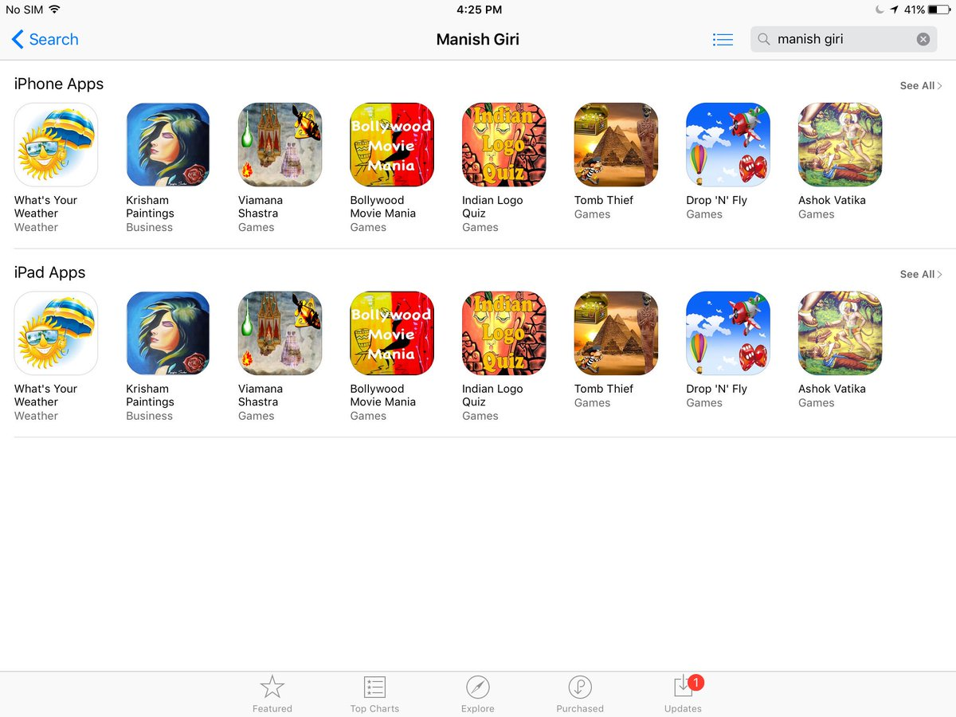

Responsibilities
• Utilize Mac OS, XCode IDE, Swift and iPhone SDK.
• Develop code to communicate with Rest API using JSON.
• Relevant automation experience on iOS and Android native client applications
• Worked with REST web services – response codes, request types, headers, etc
• Ability to capture and analyze device/crash logs.
• Understands the differences in platform behaviors, OS version differences, and device type considerations during automation.
• Configure the code to run on different supported iOS environment as well as different devices – iPhones and iPads.
• Implementation of framework in Xcode to handle UI tests.Involved in Automation for iOS native apps using XCTest and Swift
• Configure Certificates, Identifiers and Provisioning Profiles on Apple Developer account.
• Creating build and submitting to App Store for review
• Utilize Firebase and MongoDB for database. Update apps for new iOS versions and new iOS devices. Survey iTunes Connect/App Store connect for app performance, downloads, crash reports, sessions. Promote apps on social media. Manage code on storage or git for backup.

Fidelity International, London, UK
Role: Senior RPA Developer(August 2014 – August 2015)
Tools: HP ALM, SQL, Blue Prism, VB.NET, c#, Automation Anywhere, JAVA

Responsibilities:
• Designed automation solutions using Blue Prism/Automation Anywhere RPA platform for Pension Reform & Healthcare Claims.
• Took business requirements, current and future state process designs and translated them into process flows and Visual Business Objects within the Blue Prism object studio, Blue Prism process studio.
• Designed solutions utilizing RPA best practices and maintain technical responsibility for project delivery.Identifying use cases that can be automated and developing scripts using Java, AutoIT, SIKul.Designed and improved the Automation framework developed using Maven, TestNG, WebDriver Java
• Migrated Java usecases to Blue Prism. Got trained in Automation Anywhere.
• Automated usecases for Medical Billing for claims totaling over $2M, ensuring prompt and accurate payouts.
• Automated claims handling efficiency by 25% through the implementation of predictive modeling techniques. Reduced customer complaints by 40% through improved claims investigation RPA methodologies, enhancing overall customer satisfaction.
• Usecases in managing high volume of healthcare claims, expediting processing and improving overall customer experience by speeding through automation.
• Participated in the development of a comprehensive risk management bot, leading to a 35% reduction in claim disputes.
• Played a key role in processing Medicare claims ensuring accuracy and regulatory compliance through automation.

Publicis Sapient, Miami , FL
Role: Senior Automation Engineer(March 2014 – July 2014)
Tools: HP ALM, SQL, Seetest Manual, Selenium, Caliper, Eclipse, Monkeytalk, Android manager, Neoload, Fiddler, Charles, Creative QA tools-JAWS, Caliper, Adobe Photoshop, Web Developer, Firebug, User Agent

Responsibilities:
• Identified test cases that can be automated and developing scripts using Java.
• Designed and improved Automation framework developed using Maven, TestNG, WebDriver and Appium for mobile automation.
• Preparing reusable functions, which improve the robustness, re-usability, and maintainability of the test scripts using Selenium, Java and Appium
• Continuous integration using Jenkins and Git
• Create mobile testing capabilities, support mobile delivery projects and work with accounts on pre-sales activities from a QA perspective.
• Performing mobile automation using Perfecto Mobile, Seetest and Appium.
• Utilized Saucelabs for validating builds on different operating environments.
• Provide hands-on assistance to delivery team members by training them using tailored course material.
• Worked on cloud testing project, NHBlood Mobile Testing, German Mobile, and Desktop application automation.

AT&T, Atlanta, GA
Role: Senior Automation Engineer (October 2009 – May 2012)
Tools: Jenkins, XML, JSON, SQL, Rallydev for Agile, Quality Centre (HP ALM), IBM Rationale Clear Quest, JIRA, Putty, QTP, VB Script, UNIX, Amdocs Billing System.

Responsibilities:
• Automated Mobile devices like iPads & Think Pad and all latest payment/signature capture devices compatible with them.
• Worked with the requirement team and analyzed the requirements along with Design team for the scope definition.
• Worked in Amdocs Billing System. Involved in Automation framework Planning and Execution for Functional Automation.
• Creation of QTP Automation Packages, Requirement Traceability Matrix, and Review Record.
• Gave the External and Internal Walkthrough to the Client. Uploaded of Automation script Cases in the HP Quality Centre.
• Involved in API Automation by checking Logs of the Critical Projects and Enhancement. Prepared the Daily Status Reports and Lesson Learnt at the End of the Release.
• Create various documents like Low Level Design, Unit, System and Integration Test
• Prepared Test Data for the Automation script.
• Prepared Dev, UAT, Prod Environment to execute the Automation script.
• Involved in query database for end-to-end validations and data mining. Validated SOAP APIs
• Prepared automation scripts for regression test cases using QTP and VB script.

