SHASHIDHAR 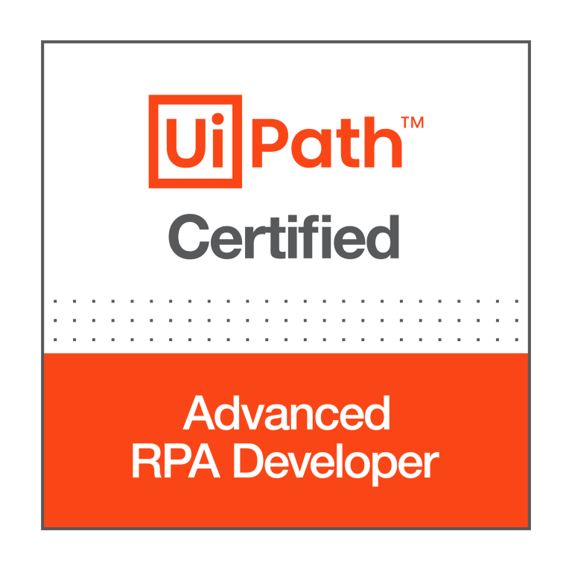 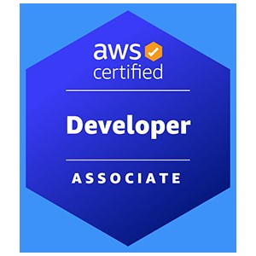
Ph: 949-791-7831 Email: s.shashi2898@gmail.com
Summary
- Around 8 years of experience in the IT industry and worked on various technologies RPA, Angular, HTML, Python, CI/CD and AWS.
- UiPath Certified Advanced RPA Developer v1.0 (UiARD).
- Conduct feasibility sessions with stake holders and SMEs to analyze their standard business processes for Robotic Process Automation.
- Expertise in developing and deploying unattended and attended bots in UiPath.
- Good experience in interacting with various applications such as Web, Excel, PDF, Text files, databases and APIs using UiPath.
- Hands on experience in working with Microsoft and Tesseract OCRs for processing PDF and image files.
- Expertise in exception handling and troubleshooting bots in UiPath.
- Hands on experience in implementing RE Framework in UiPath.
- Hands on experience in working with UiPath Orchestrator Assets, Libraries, Processes, Queues, Packages, Jobs, Triggers.
- Hands on experience in creating reusable libraries.
- Proficient in requirement gathering, creating all process documents like Process Design, Use Cases and Unit Testing etc.
- Extensive experience in writing and executing test cases in Manual testing, and Automation Testing.
- Hands on experience in creating, managing, and running Test Sets using UiPath Orchestrator and UiPath Test Robots.
- Good experience in working on Document understanding (Taxonomy, digitization) and Action center.
- Good knowledge of Machine Learning and Artificial Intelligence.
- Hands on experience in working on Data scraping activities.
- Hands on experience in working with different types of recordings.
- Hands on experience in configuring UiPath robots and setup environments.
- Worked on bot deployment into different environments i.e., DEV, SIT, UAT and Prod.
- Hands on experience invoking other language codes from UiPath such as C#.NET.
- Very good experience in developing RPA solutions using Pega Robotics (Openspan).
- Interacted with Microsoft Excel, Outlook and text files using Pega Robotics studio.
- Hands on experience in working with Reporting tools such as Splunk (using Pega robotics)
- Good experience in automating various tasks with Python.
- Worked on multiple PoCs.
- Worked on preparing Process Definition Documents (PDD) and Solution Design Documents (SDD).
- Mentoring new team members and providing training/KT to freshers.
- Strong ability to convert business requirements to automation.
- Good experience in SQL, NoSQL (MongoDB), PostgreSQL, shell scripting and C#.NET.
- Web application backend REST API utilizing Angular JS and MySQL.
- Handled operations and maintenance support for AWS cloud resources which includes launching, maintaining,
- Hands on experience with CI Server Jenkins, Build Tool Maven, and Repository Manager Artifactory.
- Developed various shell scripts and python scripts to address various production issues.
- Experienced in working with and helping junior engineers in the team to catch up with the speed.
- Experience with all stages of the SDLC and Agile Development model right from the requirement gathering to Deployment and production support.
- Involved in daily SCRUM meetings to discuss the development/progress and was active in making scrum meetings more productive.
TECHNICAL SKILLS:
RPA Tools: UiPath Studio, Orchestrator, UiPath Assistant, Document Understanding, Open Span, Test Suite.
Databases: MS SQL Server, MongoDB (NoSQL), RedShift, Oracle
Data Visualization Tools: Tableau, Alteryx
Cloud: AWS
Languages: C#.NET, VB.NET, Python, HTML, CSS, Angular, Java, JavaScript, Shell scripting
Operating System: Linux, Unix, Windows
Version Control: Git, Bitbucket, Bamboo, CI/CD, Jenkins, Docker, Kubernetes, Azure DevOps, Jira
IDEs: Visual Studio Code, Spyder, WebStorm, Eclipse

PROFESSIONAL EXPERIENCE:
SEI Investments Oaks, PA
RPA Lead Nov 2021 – Present
Worked as RPA Lead in developing and deploying various bots involving different applications using UiPath tool. Below are my responsibilities in overall bot development process:

Responsibilities:
- Worked closely with Business users in identifying and analyzing the requirements.
- Creating the design documents after understanding the use cases and the current system.
- Involved in Analysis, Estimation, Module Design, and Preparing Solution Design Documents and Unit Testing
- Developed logical automations as per the process requirement using RE Framework and performed unit testing.
- Hands on experience in developing Document Processing using UiPath OCR Document understanding module.
- Interacted with various applications from UiPath such as Web applications, Excel, CSV, Word, PDFs, API services and SharePoint.
- Followed Basic and OAuth authentication protocols to interact with different applications through API services.
- Involved in RPA Solutions reviews.
- Prepared Process Definition Documents (PDD) and Solution Design Documents (SDD).
- Documented Test cases, Test procedures and Test results.
- Experience in creating automated Test Cases in UiPath Studio and publishing them to UiPath Orchestrator.
- Involved in daily status calls to discuss the status of development.
- Followed Agile scrum methodology and was involved in all scrum ceremonies.
- Prepared Monitoring unattended bot to track all existing bot’s status and through this bot we were able to test all existing bots and take necessary action if there is any issue with any of the process.
- Followed best practices while developing bots.
- Worked on additional log parameters for better filter criteria from Kibana.
- Prepared Visualizations and Kibana Dashboards as per client requirement.
- Automated a few tasks using Python such as identifying duplicate files in a folder and moving them to separate folder in server.
- Worked on unit testing API services from Insomnia.
- Automated a task which highlights specific keywords in a pdf file using Python language.
- Worked on various tasks that reduce manual effort using Python and UiPath.
- Developed dashboards in Tableau for monitoring Machine learning model performance.

Environment: UiPath Studio, UiPath Orchestrator, UiPath Assistant, Kibana, Document Understanding, Test Suite, Unit Tests, Tableau, Jira, REST API services, C#.NET, Python, Web applications, PDFs, Confluence, SQL, bitbucket, Kanban, Git, Postman, Agile.

VANGUARD Malvern, PA
RPA Developer Sep 2018 – Oct 2021
Working as an automation engineer and am involved in developing and deploying various bots using UiPath RPA technology. Below are my responsibilities.
Responsibilities:
- Worked directly with stakeholders to capture business requirements and translate them into technical approaches and designs that can be implemented.
- Also, worked as an RPA developer and developed and deployed bots using UiPath tool.
- Automated tasks using web recorder and scheduled tasks to repeat as per requirements.
- Creating the design documents after understanding the use cases.
- Designing automated process solutions in accordance with the standard RPA design principles and conventions and performed unit testing.
- Involved in status calls daily to update the status of development.
- Prepared Visualizations and Kibana Dashboards as per client requirement.
- Worked with QA team to review the test scripts prepared by the team.
- Supported bot testing during the UAT phase and while deploying the bot in Production.
- Extensively worked with the retrieval and manipulation of data from the Oracle database by writing queries using SQL and PL/SQL.
- Hands on Experience with Agile Method and used JIRA to create Epics, tasks, and subtasks.
- Involved and improved the single page application using Restful web services and AJAX.
- Hands on experience in creating AWS services using CloudFormation templates.
- Configured Docker container for branching purposes and Implemented Docker automation solution for Continuous Integration / Continuous Delivery model.
- Created AWS Security Groups for deploying and configuring AWS EC2 instances.
- Used python Boto 3 to configure the services AWS glue, EC2, S3
- Hands on experience on bitbucket and bamboo.
Environment: UiPath Studio, UiPath Orchestrator, UiPath Robot, SQL, Oracle DB, Angular, JavaScript, HTML, CSS, AWS, Docker, Kubernetes, Jira, Web applications, Bitbucket, Bamboo, Confluence.

Geisinger Health Danville, PA
RPA Developer July 2017 – Sep 2018
Working as an RPA Developer and am involved in developing and deploying various bots using Open Span (Pega Robotics) technology. Below are my responsibilities.

Responsibilities:

- Worked as an RPA Developer and I have developed and successfully deployed various bots using Pega Robotics.
- Interacted with various applications such as Windows, Web, and Excel files for developing attended bots through Pega Robotics studio.
- Developed logical automations as per the process requirement and performed unit testing.
- Worked on Plant configuration bot to integrate with SAP windows application.
- Worked on multiple bots by interacting with Web adapters.
- Involved in daily scrum calls to update the status or progress of development activities.
- Monitoring health check of bots and debugging the exception scenarios.
- Worked on explicit logging mechanism to store exception messages.
- Installed Jenkins in standalone mode as a windows service and integrated Jenkins with different tools for continuous smooth development and release process.
- Experience developing, deploying, and operating services running in a cloud environment (AWS).
- Used Docker, Kubernetes and OpenShift to manage microservices for the development of continuous integration and continuous delivery.

Environment: Pega Robotics Studio (Open Span), Docker, Kubernetes, HTML, CSS, Java, Angular

Sagar soft Inc Hyderabad, India
Full Stack Developer Jan 2015 – Dec 2015
Responsibilities:
- Gathered specifications for the library site from different departments and users of the services.
- Assisted in proposing suitable UML class diagrams for the project.
- Wrote SQL scripts to create and maintain the database, roles, users, tables, views, procedures, and triggers in Oracle.
- Designed and implemented the UI using HTML, JSP, JavaScript and Java.
- Implemented multi-threading functionality using Java Threading API
- Extensively worked on IBM Web Sphere 6.0 while implementing the project.
- Developed the UI screens using HTML5, DHTML, XML, Java Scripts, Ajax, jQuery custom- tags, JSTL DOM Layout and CSS3.
- Strong Experience in database design using PL/SQL to write Stored Procedures, Functions, Triggers, and strong experience in writing complex queries, using OracleDB2, SQL Server and MySQL
- Building skills in the following technologies: WebLogic, Spring Batch, Spring, Java.
- Used XML SAX parser to simulate xml file which has simulated test data.
- Designed/developed Rest based service by construction URI, developed service using JAX-RS annotations and Jersey implementation.
- Used Junit, Easy mock framework for unit testing of application and implemented Test Driven Development (TDD) methodology.
- Developed integration techniques using the JMS along with Mule ESB to integrate different applications.
- Used Oracle as backend database using Windows OS. Involved in development of Stored Procedures, Functions and Triggers.
- Involved in creating single page applications using Angular JS components, directives and implemented custom directive as part of implementing reusable components.
Environment: HTML, CSS, Java, Angular, SQL, OracleDB2

CERTIFICATION:
UiPath Certified Advanced RPA Developer v1.0 (UiARD)
Amazon Web Services Certified Developer – Associate

EDUCATION:
Bachelor of Technology: Jawaharlal Nehru Technological University
Master of Science: Computer Science in Southern Arkansas University

