SHASHIDHAR 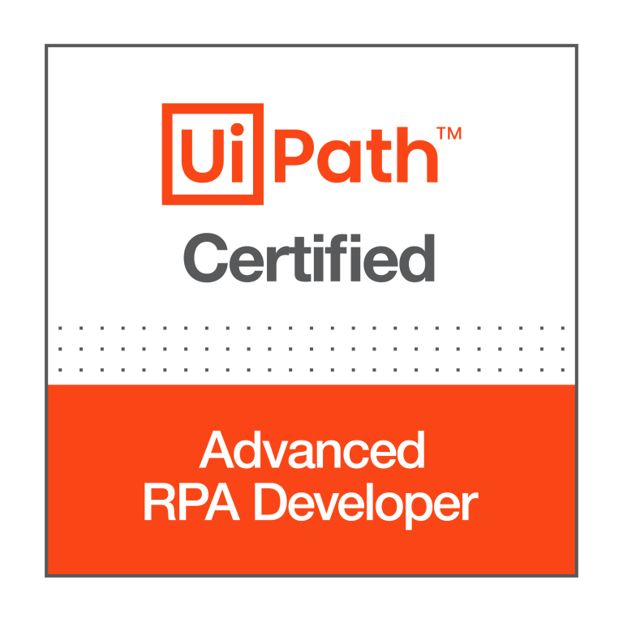 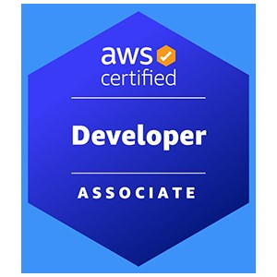
Ph: 949-791-7831 Email: s.shashi2898@gmail.com
Summary
- Around 8 years of experience in the IT industry and worked on various technologies RPA, Angular, Python, CI/CD and AWS.
- UiPath Certified Advanced RPA Developer v1.0 (UiARD).
- Conduct feasibility sessions with stake holders and SMEs to analyze their standard business processes for Robotic Process Automation.
- Well versed with UiPath Studio, UiPath Robot, UiPath Orchestrator, Document Understanding and Action Center.
- Proficient in requirement gathering, creating all process documents like Process Design, Use Cases and Unit Tests etc.
- Worked on preparing Process Definition Documents (PDD), Solution Design Documents (SDD), flow chart diagrams and roadmap of current and future processes.
- Expertise in implementing RE Framework and creating reusable libraries in UiPath.
- Expertise in working with UiPath Orchestrator Assets, Libraries, Processes, Queues, Packages, Jobs, Triggers, APIs.
- Well versed in interacting with various applications such as Web, Windows, Excel, CSV, PDF(OCR), Databases, Text files and REST APIs using UiPath.
- Involved in process assessment and feasibility study for RPA implementation by developing Proof of Concept (PoC)
- Good knowledge of Machine Learning and AI/ML Models.
- Expertise in developing and deploying unattended and attended bots in UiPath.
- Good experience in configuring UiPath robots, setup environments and monitoring RPA bots.
- Worked on bot deployment into different environments i.e., DEV, SIT, UAT and Prod.
- Hands on experience in creating custom activities using C#.Net and invoked other language codes from UiPath such as Python, VB.NET and C#.NET.
- Good knowledge of UiPath insights and dashboards.
- Hands on experience in migration of applications from Pega Robotics to UiPath.
- Very good experience in developing RPA and RDA solutions using Pega Robotics (Openspan).
- Good experience in SQL, NoSQL (MongoDB), PostgreSQL, shell scripting and C#.NET.
- Web application backend REST API utilizing Angular JS and MySQL.
- Mentoring new team members and providing training/KT to freshers.
- Good experience on cloud technologies such as AWS and Azure.
- Hands on experience in deploying processes using CI/CD.
- Used Docker, Kubernetes and OpenShift to manage microservices for the development of continuous integration and continuous delivery.
- Hands on experience with CI Server Jenkins and Build Tool Maven.
- Proficient in using monitoring tools like SPLUNK, Kibana, Dynatrace and Grafana.
- Developed various shell scripts and python scripts to address various production issues.
- Create and track tickets using Service Now for the issues that occurred during production support.
- Experience with all stages of the SDLC and Agile Development model right from the requirement gathering to Deployment and production support.
- Experience developing, deploying, and operating services running in a cloud environment (AWS).
- Involved in daily SCRUM meetings to discuss the development/progress and was active in making scrum meetings more productive.
TECHNICAL SKILLS:
RPA Tools: UiPath Studio, Orchestrator, UiPath Assistant, Open Span.
Databases: MS SQL Server, MongoDB (NoSQL), RedShift, Oracle
Data Visualization Tools: Tableau, Alteryx
Cloud: AWS
Languages: C#.NET, VB.NET, Python, HTML, CSS, Angular, Java, JavaScript, Shell scripting
Operating System: Linux, Unix, Windows
Version Control: Git, Bitbucket, Bamboo, CI/CD, Jenkins, Docker, Kubernetes, Azure DevOps, Jira, Service Now
Monitoring Tools: SPLUNK, Dynatrace, Grafana, Kibana
IDEs: Visual Studio Code, Spyder, WebStorm, Eclipse
PROFESSIONAL EXPERIENCE:
SEI Investments Oaks, PA
RPA Lead Nov 2021 – Present
Worked as RPA Lead in developing and deploying various bots involving different applications using UiPath tool. Below are my responsibilities in overall bot development process:

Responsibilities:
- Worked closely with business in identifying and analyzing the requirements.
- Creating AS-IS and TO-BE process documents after understanding the use cases and the current system.
- Involved in Analysis, Estimation, Module Design, and Preparing Solution Design Documents and Unit Testing
- Developed logical automations as per the process requirement using RE Framework and performed unit testing.
- As an onsite lead, I acted as a bridge between business and our offshore team, and I support operation during non-business hours.
- Interacted with various applications from UiPath such as Web applications, Excel, CSV, Word, PDFs, API services and SharePoint.
- Expertise in handling business and technical exceptions using UiPath.
- Worked on JSON serialization and deserialization while utilizing API services.
- Followed Basic and OAuth authentication protocols to interact with different applications through API services.
- Involved in RPA Solutions reviews.
- Prepared Process Definition Documents (PDD) and Solution Design Documents (SDD).
- Worked on unit testing in parallel with development work.
- Involved in daily status calls to discuss the status of development.
- Followed Agile scrum methodology and was involved in all scrum ceremonies.
- As part of production support, I monitor all bot’s status, log messages, and debug any issues.
- Followed best practices while developing bots.
- Worked on additional log parameters for better filter criteria from Kibana.
- Prepared Visualizations and Kibana Dashboards as per client requirement.
- Worked on unit testing API services from Insomnia.
- Worked on various tasks that reduce manual effort using Python and UiPath.
- Automated a few tasks using Python (pandas, pymupdf) such as identifying duplicate files in a folder, highlighting specific keywords in a pdf file, and moving them to separate folder in server.
- Developed dashboards in Tableau for monitoring Machine learning model performance
Environment: UiPath Studio, UiPath Orchestrator, UiPath Assistant, Kibana, Test Suite, Unit Tests, Tableau, Jira, JSON, REST API services, C#.NET, Python, Web applications, Scrum, PDFs, Confluence, SQL, bitbucket, Kanban, Git, Postman, Agile.

VANGUARD Malvern, PA
RPA Developer Sep 2018 – Oct 2021
Working as an automation engineer and am involved in developing and deploying various bots using UiPath RPA technology. Below are my responsibilities.
Responsibilities:
- Worked directly with stakeholders to capture business requirements and translate them into technical approaches and designs that can be implemented.
- Also, worked as an RPA developer and developed and deployed bots using UiPath tool.
- Automated tasks using web recorder and scheduled tasks to repeat as per requirements.
- Creating the design documents after understanding the use cases.
- Designing automated process solutions in accordance with the standard RPA design principles and conventions and performed unit testing.
- Experienced in extracting structured and unstructured data using web data extraction and export the data to Excel or Database.
- Involved in status calls daily to update the status of development.
- Worked with QA team to review the test scripts prepared by the team.
- Supported bot testing during the UAT phase and while deploying the bot in Production.
- Extensively worked with the retrieval and manipulation of data from the Oracle database by writing queries using SQL and PL/SQL.
- Hands on Experience with Agile Method and used JIRA to create Epics, tasks, and subtasks.
- Involved and improved the single page application using Restful web services and AJAX.
- Hands on experience in creating AWS services using CloudFormation templates.
- Configured Docker container for branching purposes and Implemented Docker automation solution for Continuous Integration / Continuous Delivery model.
- Experienced with Kubernetes to orchestrate the deployment, scaling and management of Docker Containers. Worked on Microservices and deploying Microservices using Kubernetes YAML files.
- Created AWS Security Groups for deploying and configuring AWS EC2 instances.
- Hands on experience on bitbucket, bamboo and Service Now.
Environment: UiPath Studio, UiPath Orchestrator, UiPath Robot, SQL, Oracle DB, Angular, JavaScript, HTML, CSS, AWS, Docker, Kubernetes, Jira, Web applications, Bitbucket, Bamboo, Confluence.
Geisinger Health Danville, PA
RPA Developer July 2017 – Sep 2018
Working as an RPA Developer and am involved in developing and deploying various bots using Open Span (Pega Robotics) technology. Below are my responsibilities.

Responsibilities:

- Worked as an RPA Developer and I have developed and successfully deployed various bots using Pega Robotics.
- Interacted with various applications such as Windows, Web, and Excel files for developing attended bots through Pega Robotics studio.
- Automated manual steps in claims processing.
- Developed logical automations as per the process requirement and performed unit testing.
- Worked on Plant configuration bot to integrate with SAP windows application.
- Worked on multiple bots by interacting with Web adapters.
- Integrated bot logs into Splunk through REST APIs.
- Involved in daily scrum calls to update the status or progress of development activities.
- Monitoring health check of bots and debugging the exception scenarios.
- Worked on explicit logging mechanism to store exception messages.
- Installed Jenkins in standalone mode as a windows service and integrated Jenkins with different tools for continuous smooth development and release process.
- Experience developing, deploying, and operating services running in a cloud environment (AWS).

Environment: Pega Robotics Studio (Open Span), Docker, Kubernetes, HTML, CSS, Java, Angular, Splunk

Sagar soft Inc Hyderabad, India
Full Stack Developer Jan 2015 – Dec 2015
Responsibilities:
- Gathered specifications for the library site from different departments and users of the services.
- Assisted in proposing suitable UML class diagrams for the project.
- Wrote SQL scripts to create and maintain the database, roles, users, tables, views, procedures, and triggers in Oracle.
- Designed and implemented the UI using HTML, JSP, JavaScript and Java.
- Implemented multi-threading functionality using Java Threading API
- Extensively worked on IBM Web Sphere 6.0 while implementing the project.
- Developed the UI screens using HTML5, DHTML, XML, Java Scripts, Ajax, jQuery custom- tags, JSTL DOM Layout and CSS3.
- Strong Experience in database design using PL/SQL to write Stored Procedures, Functions, Triggers, and strong experience in writing complex queries, using OracleDB2, SQL Server and MySQL
- Building skills in the following technologies: WebLogic, Spring Batch, Spring, Java.
- Used XML SAX parser to simulate xml file which has simulated test data.
- Designed/developed Rest based service by construction URI, developed service using JAX-RS annotations and Jersey implementation.
- Used Junit, Easy mock framework for unit testing of application and implemented Test Driven Development (TDD) methodology.
- Developed integration techniques using the JMS along with Mule ESB to integrate different applications.
- Used Oracle as backend database using Windows OS. Involved in development of Stored Procedures, Functions and Triggers.
- Involved in creating single page applications using Angular JS components, directives and implemented custom directive as part of implementing reusable components.
Environment: HTML, CSS, Java, Angular, SQL, OracleDB2

CERTIFICATION:
UiPath Certified Advanced RPA Developer v1.0 (UiARD)
Amazon Web Services Certified Developer – Associate

EDUCATION:
Bachelor of Technology: Jawaharlal Nehru Technological University - 2015
Master of Science: Computer Science in Southern Arkansas University - 2017

