# Objective

To be a part of a growing organization as a Product Owner and aid in accomplishment of organizational objectives by utilizing my knowledge in Software Processes.

# Experience Summary

* Over 12 years of experience in IT industry with expertise in Software testing and product ownership processes
* Ensuring process compliance and process improvements in the projects
* Analyzing Business Requirements and converting them into User stories
* Great experience in answering product related queries promptly from IT teams
* Collaborating and strategizing with the business and engineering teams
* Collaborating on product demonstrations for customers and other stakeholders
* Setting up meetings with business, Architecture and Engineering teams to discuss and finalize requirements
* Preparing test plans and test cases to ensure effective quality assurance testing and a fully functional application
* Preparing test summary reports
* Good experience in all phases of Software Development Lifecycle (SDLC) such as development, testing, migrating and production support
* Remarkable experience in designing Testing processes and developing source to target mappings
* Proven experience in utilizing databases like Teradata, SQL, PL/ SQL Developer
* Analyzing requirements and providing work effort estimates
* Creating design specification and operational documents
* Developing test cases and planning to complete unit testing
* Exhaustive experience in SDLC, specialization in design and development of ETL solutions
* Work with new fast track models of SDLC like Structured Iterative, SAFe Agile Methodology
* Performing Unit Testing/ SIT Testing and prepared testing documents are per the Client requirement
* Certified in Integrated Project Management Systems (IPMS) for Project Leaders
* Trained in integrated Quality Management Systems (IQMS)

# Skills Summary

* Excellent analytical, problem solving skills
* Superior communication, interview and presentation abilities
* Expertise in Rally, MS Office
* Experience in Retail, Manufacturing and Assurance domains
* Ability to meet rigorous deadlines
* Learning agility
* Self-motivated and hard working

**Technical Skills**

|  |  |
| --- | --- |
| **ETL Tools** | Informatica 9.6.1/9.5.1 |
| **DB Tools** | Toad |
| **Programs** | MS Word, PowerPoint, Excel |
| **Database** | PL/ SQL Developer, Teradata 14/13/12 |
| **Testing Tools** | Quality Center, Control-M, Jira, Rally, SoapUI, WinSCP, TeamTrack, Postman |
| **Languages** | PL/SQL, SQL, Java/J2EE |
| **Operating System** | Windows, Macintosh |

**Professional Experience CVSHealth, USA**

**Product Specialist – Product Specialist Present**

* Understand business needs and draft User stories based on the research and understanding
* Discuss the User stories with business teams and product managers/ owners to ensure that the drafted user stories are in line with the business requirements.
* Set up IT refinement sessions and discuss the business needs and architecture with the IT teams, which includes, Development, QA and Architecture etc.
* Discuss within different interface teams as and when required for an impact across multiple teams
* Perform updates and finalize the user stories based upon inputs from Business and IT teams, negotiate within teams, if required.
* Respond to the defects that are assigned as ‘BA review’ based upon business vision
* Update and review Functional requirements document to ensure that the requirements are placed in an orderly fashion
* Research and analyze, beforehand, any possible challenges and impact for business teams post production deployment
* Identify any issues or defects that arise within or across the teams that might impact the project

# CVSHealth, USA

Quality Assurance – Senior Analyst **Feb 2021- July 2022**

* Develop the test strategy/plan for small to medium test efforts and seek approval from the project stakeholders.
* Lead and actively participate in test case development and execution activities and is accountable for the quality outcomes for assigned projects.
* Lead and provide guidance as needed to the analyst staff.
* Organize review meetings for manual test artifacts and gather approvals for all related QA items.
* Assist team members with the identification/creation of the test data required to support test execution.
* Manage multiple projects and schedule the timeline for testing process.
* Write complex PL/SQL testing queries for User Acceptance Testing.
* Log defects found during test using the appropriate defect management tool and confirm correction once fixed.
* Monitor defects reported against the assigned projects and ensure they are brought to closure prior to the end of the QA phase.
* Coordinate, lead, and drive end-to-end test activities and artifacts as applicable for projects in testing.

# CVSHealth, ITECS USA

**QA Lead Analyst June 2018- Feb 2021**

* The daily activities involve regular meetings with the CVS personnel to gather requirements, review designs, discuss and dissolve technical issues and change requests.
* Perform Functional, Smoke, Integration, System, Back-end and User Acceptance testing.
* Review the architecture and functional requirement documents.
* Review the technical design document and unit test plan so as to ensure proper testing.
* Prepare test plans and test cases to ensure effective quality assurance testing and a fully functional application.
* Deriving Test Scenarios and Documenting Test Cases in HP QC tool.
* Defect Reporting using Test Management Tool Team Track.
* Review of regression test cases and application landscape.
* Provide support to various testing groups on test data setup for new functionality, existing functionality and triaging test environment issues in various phases of testing (System, Integration, User Acceptance).
* Delivering projects with complexity at scale, meeting business goals and objectives working with cross- functional teams.
* Work with new fast track models of SDLC like Structured Iterative, Agile Methodology.
* Log and group defects and generate detailed Defect reports using TeamTrack.
* Follow-up with customers on satisfaction of analysis, if a defect is raised then follow it till the closure of the defect and ensure proper route for it close, monitor or slotting for future release.
* Prepare and share Daily & Weekly status report with Client personnel.

# Wolters Kluwer, ITECS USA

**Systems Engineer Nov 2017- June 2018**

* Highly skilled in analyzing business requirements and converting business requirements into code.
* Extensive knowledge of creating Business requirement and Technical documents.
* Seasoned in all phases of Software Development Lifecycle (SDLC) such as development, testing, migrating, administrating and production support.
* Preparing test plans and test cases to ensure effective quality assurance testing And a fully functional application.
* Performing application testing as well as front end testing.
* Preparing test summary report.
* Defect Reporting using Test Management Tool Quality Center.
* Developed masking routines using Informatica mappings using different masking rules and Data Masking transformation.
* Developed various complex mapping using multiple sources and targets in different databases, flat files and loading them into Teradata.
* Write complex PL/SQL testing queries for User Acceptance Testing.
* Face to face discussions with various Project Owners and team members about the quality of the documents prepared by the corresponding team members. Causal Analysis was carried out particularly for the teams that received a low Customer Satisfaction Index (CSI).
* Ensuring timely feedback from the Client as well as Project Owners upon the improvements made and working upon it.
* Worked both individually and collaboratively, usually under no supervision.
* Proven experience under changing environments with changing priorities and under alarming deadlines.

# Assurance Infra Testing, TCS India Apr 2014 - Feb 2017 ETL Tester

* Working closely with Development and Design team in order to understand Business Requirements.
* Documented Business Requirements and assessed changes required to existing processes and procedures
* Translated Business Requirements into Data Warehouse design.
* Good understanding on applying rules of Data Masking transformation using Informatica PowerCenter and loading the data into targets.
* Responsible for capturing Unit and Integrated test results.
* Responsible for updating QC with proper update for the raised ticket.
* Created reusable transformations, mapplets, worklets using Transformation Developer, Mapplet Designer and Worklet Designer.
* Handled Post-production issues and delivered all assignments/ projects within specified timelines.
* Developing Project Profile and Project Plan for the project.
* Organized, edited and maintained technical records and files according to set standards for order, clarity, conciseness, style and terminology.

# CVS Caremark, Gurgaon, TCS India Oct 2011- March 2014 Production Support Executive

* Working closely with Development and Design teams to understand Business Requirements.
* Performed major role in designing and masking the data.
* Developed masking routines using Informatica mappings using different masking rules and Data Masking transformation.
* Created Informatica PowerCenter mappings, sessions, workflows and worklets.
* Wrote Teradata queries to unit test Data Masking applications.
* Carrying out data masking activities by triggering jobs in Informatica and monitoring these jobs.
* Analyzing the job failure issues and reporting to the onsite team.
* Identifying and analyzing the issue if a particular workflow failed and looking for the possible workarounds.
* Suggesting solutions for the failed jobs to the onsite team and working with them for troubleshooting.
* Preparing several documents like Performance Data sheet for the jobs triggered reporting their status (succeeded/ failed) and other statistics related to the onsite team.
* Developing Project Profile for the project.
* Setting up meetings with onsite team to understand Client expectations.
* Defect Reporting using Test Management Tool, Quality Center.

# Education

* B. Tech in Electrical Engineering from Rajasthan Technical University, Kota, Rajasthan in India
* Certification in Informatica PowerCenter Foundation in October 2015
* Certification in Software Testing Skills in October 2014
* Certified in Integrated Project Management Systems (IPMS)
* Trained in Integrated Quality Management Systems (IQMS)
* Received On the Spot award and Employee of the month award twice

**Certifications**

**Certificate in Software Testing Skills:**

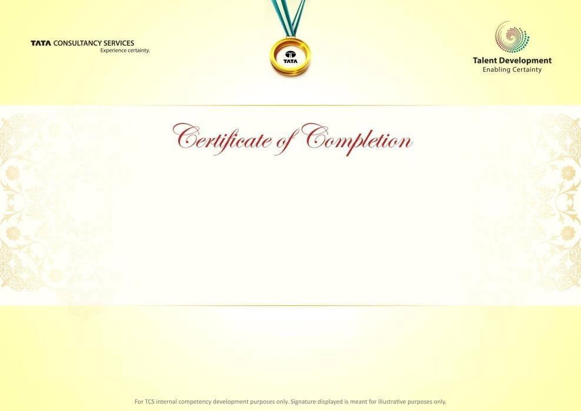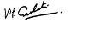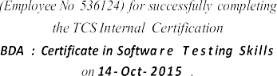

**Digital: BigData and Hadoop Ecosystems:**

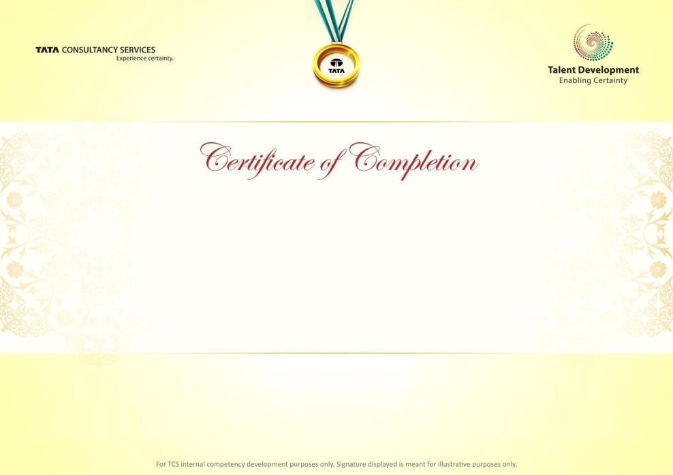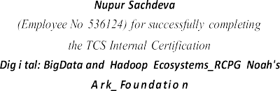

**Informatica Powercentre foundation:**

