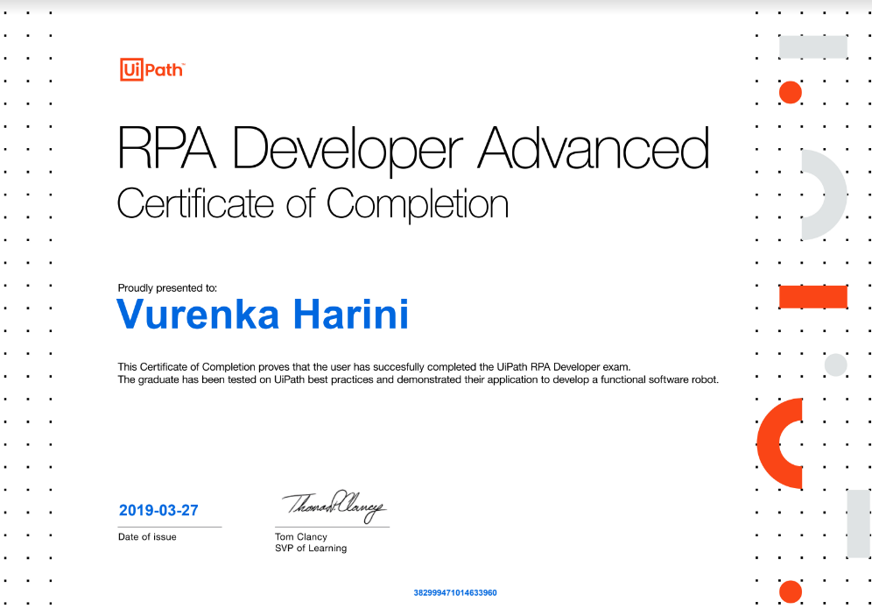
VURENKA HARINI
harinivurenka@gmail.com
+1 301 201 4178

Certified RPA Developer

PROFESSIONAL SUMMARY:
- 7+ years of experience in RPA automating the business process using RPA Tools UiPath and Blue Prism.
- Identifying new process opportunities and accurately analyzing and estimating new processes, quickly assessing feasibility.
- Configuring new UiPath processes and objects using core workflow principles that are efficient, well structured, maintainable, and easy to understand.
- Implemented UiPath features such as Document understanding, Optical character recognition (OCR), Salesforce platform, Image Recognition, Basic/Desktop/Web and Citrix automations, Text Analysis, Screen Scraping, PDF processing, Excel integration, MuleSoft Integration, Email automation, API automation, StudioX, Task Capture, Workflow Analyzer, Custom Activities etc.
- Developed highly complex workflows in UiPath using Re-framework and Enhanced Re-framework.
- Experience in creating attended and unattended bots, also worked on process mining, task capture, AI Centre, Machine Learning, Chatbots and Document Understanding
- Experience in using UiPath Orchestrator functionalities like Bots, Triggers, Work Queues, Processes, Assets, Jobs, Schedulers, and Environments etc.
- Understanding of workflow-based logic and the ability to both understand a business process from a workflow diagram and to conceptualize it as an automated solution.
- Communicating with uipath and Blueprism on software related issues, suggested improvements and participating with other users in the community.
- Working within project planning constraints, communicating any identified project risks and issues to the delivery/project manager accordingly and providing inputs to the change control process.
- Experience in creation of Solution Design Documents (SDD) and operational manual, configuration Workbook and Daily Status Report within the automation space.
- Supporting, maintaining existing processes and implementing change requirements as part of a structured change control process.
- Mentoring colleagues through the UiPath training and accreditation program
- Always stayed updated on industry trends and advancements in RPA, incorporating best practices into automation projects - providing advice, guidance and development techniques.
- Designed and developed Power BI reports and dashboards based on business requirements.
- Designed and developed reusable RPA solutions using Uipath, Blue Prism and Power Automate
- Develop strategies for effective workflow automation using Power Automate and provide ongoing support and maintenance for these solutions.
- Worked with Business Analysts, Scrum Masters, QA Analysts, Product Owners, and other cross-functional resources to define and deliver business impacting projects.
- Design and develop UiPath workflows that include NLP functionalities and also Integrate NLP activities and components into existing or new automation processes.
- Experience in development and infrastructure tools like GITHIB, GITLAB, Jira, Confluence, Bitbucket and Jenkins
- Understanding the complete Software Development Life Cycle (Waterfall and Agile).
- Set up and configure the CI/CD pipeline for UiPath projects.
- Lead the team of 4 and help them overcome challenges and also mentor new joiners to the team.
- Proficient in using Relational Databases like Oracle and My SQL.

TECHNICAL SKILLS:

RPA Tools | UiPath, Blue Prism, Power Automate, Automation Anywhere
Methodologies | Agile, Waterfall
Management Tools | Jira, Rally
Development Tools | GIT, ADO, Jenkins, Confluence, Power BI
Databases | MS-SQL, SQL SERVER
Web Development Tools | HTML, CSS, JSON, XML
Programming Languages | C, Java, VB.Net

WORK EXPERIENCE

Client: Bank of America Oct 2022–Till date

Project Name: Transaction Exceptions

Role: Sr RPA Developer

Project Description:

Transaction exceptions is a process where it includes CBS application automation. Connection is to be done using terminal sessions. In this all the accounts data will be modified based on the conditions. For some of the accounts, their credit amount will be pushed to general ledger accounts. One other condition is to check the status of that account and send email to respective users. One other sub process is about giving loan based on their available balance and overdraft amount.

Roles and Responsibilities:
- Responsible for understanding the requirements thoroughly and helped in creating a high-level design document using BPMN format.
- Implemented the dispatcher and performer approach with RE framework.
- Terminal session automations have been implemented for connecting applications.
- Email automation has been successfully implemented for sending the output report to stakeholders.
- Created solution design document and also to be flow using BPMN format.
- Provided Go-Live and controlled release support by troubleshooting and fixing any production issues.
Environment: UiPath Studio, UiPath Orchestrator, Git Source Code, BPMN

Project Name: NSF Commercial

Role: Sr RPA Developer

Project Description:
This process decisions debits from a commercial account when it has gone into NSF status the previous day and there has been qualifying deposits made afterward which could allow some items to be paid. When an amount is due to be paid from an account in an NSF Commercial scenario, the current available dollar amount in the customer account is confirmed. The overdraft limit is confirmed. The available dollar amount is combined with the overdraft limit, and all qualifying deposits. This process reviews the NSF debits and marks for payment any that now have sufficient funds to cover the amount

Roles and Responsibilities:
- Responsible for creating SDD documents and the flow using BPMN format.
- Exception handling at business and application level has been successfully done.
- Integrate and connect different applications and services.
- Terminal session automations have been implemented for connecting applications.
- Utilize UiPath activities and document understanding features to extract relevant information from documents
- Implement OCR technologies and integrate them into the automation process.
- Email automation has been successfully implemented for sending the output report to stakeholders.
- Created solution design document and also to be flow using BPMN format
- Provided Go-Live and controlled release support by troubleshooting and fixing any production issues
Environment: UiPath Studio, UiPath Orchestrator, Document Understanding, ADO, Jira, BPMN

Client: City National Bank Feb 2020– Apr 2022

Project Name: Sanction Screening Vendor
Role: Sr RPA Developer

Project Description:

Sanction Screening Vendor verifies the list of vendor employees in various websites that hold the list of any criminal suspects. Right after the verification the list of vendor employees with updated matched scenario would be sent back to the client. The wholesome process of verification and updating has been automated in Uipath in combination with SQL database

Roles and Responsibilities:
- Web based automation was used for verifying each employee individually in different websites.
- Email automation has been implemented for fetching input data from outlook, sending the output
report and reporting error mail in case of failure to stakeholders.
- Database automation has been used for inserting data into tables in SQL, comparing them with the
databanks, updating the matching records to the output table.
- Excel automation for handling various modifications within Excel.
- Multi bot implementation for processing of matched data.
- Exception handling at business and application level has been successfully done.
- Testing the bot with various scenarios and updating the bot as per requirement
Environment: Uipath, ADO, Git Source Code, Agile Scrum, SQL Server 2021

Project Name: Employee Spreadsheet
Role: Sr RPA Developer

Project Description:

Daily process of downloading the file from Network drive and executing macros to create an output file. If the input files are not present in the network drive it should send an exception email else, it should execute macros and manipulate data in the excel sheets. Output sheet must be saved to the network drive and the older files must be transferred to another folder.

Roles and Responsibilities:
- Excel automation was implemented for executing the macros also updating the sheet columns and rows.
- Create environments dedicated to specific projects to keep related flows, connectors, and data separate.
- Use environments to organize resources based on different departments within an organization.
- Developed BOTS using Power Automate to automate and accelerate 80% of standard business process with minimum human intervention for remaining non-standard processes.
- Worked on Error handling.
- Added Delay between the activities as required avoiding the Bot failure.
- Created DSD (Development specific document) and Operation Handbook for the process
- Bot has been scheduled through the scheduler and runs on daily frequency.
Environment: Power Automate Flows, Microsoft PDF Data Extraction, ADO

Client: Baylor Scott and White Health Nov 2016– Jan 2020

Project Name: MSS - Managerial Self Service

Role: RPA lead

Project Description:

Basic objective of MSS is that Managers use PeopleSoft to make changes for their employees. This includes, but not limited to, changing hours worked, recording promotions, and transferring departments. These changes generate transactions which are returned by queries run daily. The transactions output by those queries are used by this process. It is possible for errors to exist, and the Bot must identify and correct many of these errors

Roles and Responsibilities:
- Migrated this use case from Blue Prism to UiPath
- Responsible for providing the detailed design document and solutions.
- Created the several reusable components for the applications used in the process.
- Implemented the dispatcher and performer approach with Enhanced RE framework for BOT workload management with help of UiPath queue management
- Worked on various Selector issues and used Attach window activity for performing a set of actions on a particular screen.
- Web based automation for logging in and processing Peoplesoft and Sharepoint.
- Email automation has been successfully implemented for sending the output report to stakeholders.
- Creating design document, Application information document and the testing documents.
- Involved in weekly and monthly discussion activities.
- Provided Go-Live and controlled release support by troubleshooting and fixing any production issues
- Attended online meetings to demonstrate the capabilities of RPA for on-going projects
Environment: UiPath Studio, UiPath Orchestrator, Git Source Code, XML, JSON, SQL and Migrated the project from Blue Prism to UiPath

Project Name: EMP New Hires
Role: RPA Developer

Project Description:

Weekly process of downloading the report from Sharepoint and executing a series of macros to generate the output file. This involves importing the data from one the input sheet downloaded from Sharepoint and downloading RBA database file for connectivity. After macro execution, exceptions are deleted from excel and final sheet with output data is prepared. Output sheet is uploaded back to Sharepoint, and the older files are achieved. Email with the Sharepoint link is sent to the end user.

Roles and Responsibilities:
- Web Based and Excel Automation was implemented in the process
- Involved in End-to-End development of Business.
- Proactively designed RPA Tasks as per the application and business requirements.
- Updated the day-to-day progress and made generic enhancements to the Bots designed. Used GIT as a centralized version control system to maintain the code.
- Created DSD (Development specific document) and Operation Handbook for the process
- Deployed the automation solution into QA and UAT environments.
- Bot has been scheduled through the scheduler and runs on weekly frequency.
Environment: Blue Prism, Jira and SQL

Project Name: Welcome Letter Correspondence
Role: RPA Developer

Project Description:

Welcome Letter Correspondence is all about downloading different types of files from an application. Based on the information present, data will be modified on the files and routed to people via email

Roles and Responsibilities:
- Email automation has been implemented for fetching input data from outlook, sending the output report and reporting error mail in case of failure to stakeholders.
- Pdf automation for handling various modifications within pdf.
- Multi bot implementation for processing different files.
- Queues have been handled for processing.
- Exception handling at business and application level has been successfully done.
Environment: Blue prism, ADO and SQL

Project Name: Payer Alerts – Medicare Beneficiary Identifier

Role: RPA Developer

Project Description:

To login to the EHR system and apply rules to filter patients whose MBI number is either invalid or missing. Patient details must be fetched and should be cross checked with novitosphere website. Depending on details it should be updated back to the EHR System.

Roles and Responsibilities:
- Worked with Business Analysts to prepare Process Definition Document (PDD) and created Solution Design Document (SDD)
- Developed workflows to retrieve required patient details from the EHR system.
- Utilized various UiPath Activities Web, Database, Data Scraping, Queue Activities, Error handling, Try Catch etc.
- Exception handling at business and application level has been done.
- Interacted with mail services such as Outlook to send the output report and reporting error mail in case of failure to stakeholders
- Implemented RE Framework and created Dispatcher and Performer processes to add the data to Queue and process the same according to the business logic.
- Multi bot implementation has been done for processing a large number of patient records.
- Used various UiPath Orchestrator functionalities like Bots, Processes, Assets, Jobs, Schedulers, Logging, Triggers, Recovery Methods, and Application Credentials.
- Created and documented test procedures and scenarios for Pre-UAT phases supporting the operational teams during UAT (User Acceptance Testing) and rollout phases.
- Coordinating with teams and overseeing delivery
Environment: UiPath Studio, UiPath Orchestrator, Git Source Code and SQL

Project Name: Payer Alerts – Medicare is Not Primary

Role: RPA Developer

Project Description:

To login to EHR system and apply rule to filter patients who do not have primary insurer as Medicare. Patient details must be fetched and should be cross checked with websites like novitosphere and availity. Depending on details the coverage must be updated, or it should be deferred.

Roles and Responsibilities:
- Bot was developed to login to the EHR System and websites, check for all the necessary conditions and modify the coverage as per the requirement.
- Database activities were implemented to handle the dynamic supply of the parameter and the values from one report to another.
- Multi bot implementation has been done for processing a large number of patient records.
- Email automation was used that includes email body in html through database.
- Document each unit test case, functional validation for production change request.
Environment: UiPath Studio, UiPath Orchestrator, Git Source Code and SQL

CERTIFICATIONS:

  - UiPath –ADVANCED DEVELOPER
  - UiPath – ORCHESTRATOR
  - UiPath AI FABRICS & DOCUMENT UNDERSTANDING
  - Blue Prism Developer Foundation

