SHASHIDHAR 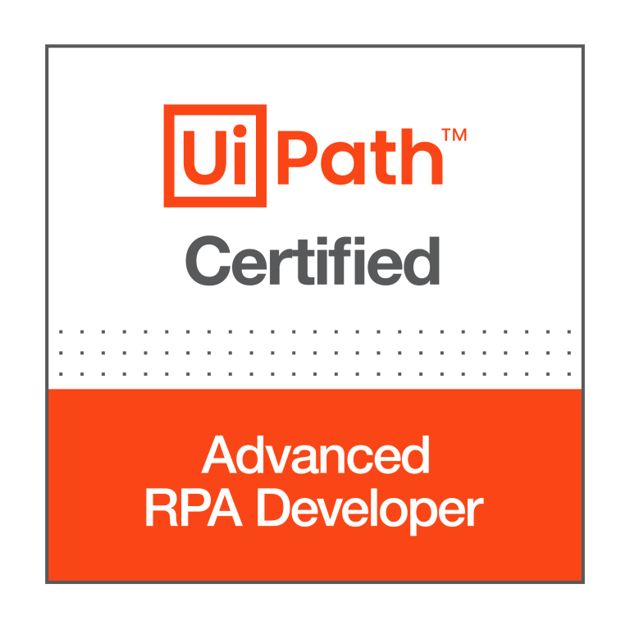 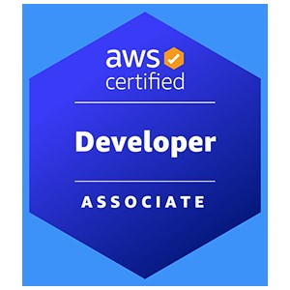
Ph: 949-791-7831 Email: s.shashi2898@gmail.com
Summary
- Total 6+ years of experience in IT industry and worked on various technologies RPA, Angular, HTML, Python and AWS.
- UiPath Certified Advanced RPA Developer v1.0 (UiARD).
- Expertise in developing and deploying unattended and attended bots in UiPath.
- Good experience in interacting with various applications such as Web, Excel, PDF, Text files and APIs using UiPath.
- Hands on experience in working with Microsoft and Tesseract OCRs for processing PDF and image files.
- Expertise in exception handling and troubleshooting bots in UiPath.
- Hands on experience in implementing RE Framework in UiPath.
- Hands on experience in working with UiPath Orchestrator Assets, Libraries, Processes, Queues, Packages, Jobs, Triggers.
- Hands on experience in working on Data scraping activities.
- Hands on experience in working with different types of recordings.
- Hands on experience in configuring UiPath robots and setup environments.
- Worked on bot deployment into different environments i.e., DEV, SIT, UAT and Prod.
- Hands on experience invoking other language codes from UiPath such as C#.
- Web application backend REST API utilizing Angular JS and MySQL.
- Developed user interface screens and validations using HTML, Angular JS, Bootstrap, jQuery, Node JS, and CSS.
- Handled operations and maintenance support for AWS cloud resources which includes launching, maintaining,
- Experience in writing JUnit Test cases for Java and J2EE applications.
- Experience in Graphic and User Experience Design and Transforming Web/Graphic Designers Static Mockups into hand code using HTML and CSS.
- Developed various shell scripts and python scripts to address various production issues.
- Experienced in working with and helping junior engineers in the team to catch up with the speed.
- Experience with all stages of the SDLC and Agile Development model right from the requirement gathering to Deployment and production support.
- Involved in daily SCRUM meetings to discuss the development/progress and was active in making scrum meetings more productive.
TECHNICAL SKILLS:
RPA Tools: UiPath Studio, Orchestrator, UiPath Assistant
Databases: MS SQL Server, MongoDB (NoSQL), RedShift
Data Visualization Tools: Tableau
Cloud: AWS
Languages: C#, Python, HTML, Angular, JavaScript, Shell scripting
Operating System: Linux, Unix, Windows
Version Control: Git, Bitbucket, Bamboo, Jenkins
IDEs: Visual Studio Code, Spyder, WebStorm, Eclipse

PROFESSIONAL EXPERIENCE:
SEI Investments Oaks, PA
RPA Developer Nov 2021 – Present
Worked as an RPA developer in developing and deploying various bots involving different applications using UiPath tool. Below are my responsibilities in overall bot development process:

Responsibilities:
- Worked closely with Business users in identifying and analyzing the requirements.
- Creating the design documents after understanding the use cases and the current system.
- Involved in Analysis, Estimation, Module Design, and Preparing Solution Design Documents and Unit Testing
- Developed logical automations as per the process requirement and performed unit testing.
- Interacted with various applications from UiPath such as Web applications, Excel, CSV, Word, PDFs, API services and SharePoint.
- Followed Basic and OAuth authentication protocols to interact with different applications through API services.
- Involved in RPA Solutions reviews.
- Involved in daily status calls to discuss the status of development.
- Followed Agile scrum methodology and was involved in all scrum ceremonies.
- Prepared Monitoring unattended bot to track all existing bot’s status and through this bot we were able to test all existing bots and take necessary action if there is any issue with any of the process.
- Followed best practices while developing bots.
- Worked on additional log parameters for better filter criteria from Kibana.
- Prepared Visualizations and Kibana Dashboards as per client requirement.

Environment: UiPath Studio, UiPath Orchestrator, UiPath Assistant, Kibana, Jira, REST API services, C#, Python, Web applications, PDFs, Confluence, SQL, bitbucket, Kanban, Git, Postman.

VANGUARD Malvern, PA
Software Engineer Sep 2018 – Oct 2021
Responsibilities:
- Contributed to all phases of development lifecycle and developed and deployed new features to facilitate related procedures and tools.
- Also, worked as an RPA developer and developed and deployed bots using UiPath tool.
- Designing automated process solutions in accordance with the standard RPA design principles and conventions and performed unit testing.
- Worked with QA team to review the test scripts prepared by the team.
- Supported bot testing during the UAT phase and while deploying the bot in Production.
- Hands on Experience with Agile Method and used JIRA to create Epics, tasks, and subtasks.
- Experienced in implementing Service-oriented architecture and Web Services using SOAP, RESTFUL.
- Involved and improved the single page application using Restful web services and AJAX.
- Strong understanding in using controllers, modules, directives, factories, services, dependency injection and digest cycle in AngularJS.
- Hands on experience with build tools like ANT, Maven, and logging tools like Log4J
- Hands on experience in creating AWS services using CloudFormation templates.
- Implemented UI pages with JSP, HTML5, CSS3 using JavaScript libraries.
- Developed a single page web application by using Angular 7 TypeScript.
- Involved in the extensive usage of HTML5, CSS3, jQuery, JavaScript, and Ajax for client-side development and validations.
- Proficient in developing Single Page Applications (SPA) and Dependency Injection using JavaScript MVC framework such as AngularJS& Angular 7, Webpack and grunt.
- Created AWS Security Groups for deploying and configuring AWS EC2 instances.
- Hands on experience in creating AWS services using CloudFormation templates.
- Used python Boto 3 to configure the services AWS glue, EC2, S3
- Hands on experience on bitbucket and bamboo.
Environment: UiPath Studio, UiPath Orchestrator, UiPath Robot, Angular, JavaScript, HTML, CSS, AWS, Jira, Web applications, Bitbucket, Bamboo, Confluence.
CVS Pharmacy Woonsocket, RI
Full Stack Developer July 2017 – Sep 2018
Responsibilities:
- Used Spring Boot, Spring Security to build Microservices and deployed to AWS cloud.
- Used Spring Cloud AWS Core, Spring Cloud AWS Context, and Spring Cloud AWS Messaging.
- Utilized AWS Lambda platform to upload data into AWS S3 buckets and to trigger other Lambda Functions Including AWS EC2, MongoDB focusing on high-availability, fault tolerance, and auto- scaling.
- Implemented and experienced in creating s3 buckets creation and IAM role in non-prod region.
- Worked with Spring modules like Spring Core, Spring AOP, Spring Security and Spring MVC.
- Implemented Batch jobs using Spring Batch to ensure data integrity and consistency in the job.
- Deployed and tested the applications on Application Server JBOSS.
- Worked on Jenkins for continuous integration with Gradle and GitHub.
- Implemented authentication and authorization for the application using Spring Security.
- Worked on Docker container management along with volumes, container-based DB and services, Docker Art factory configuration and setup.
- Participating in Sprint meetings, demonstration of the applications, code review and production support.
Environment: Java, Angular, JavaScript, HTML, CSS, Ant, Maven, Docker, Git, Docker, AWS.
CERTIFICATION:
UiPath Certified Advanced RPA Developer v1.0 (UiARD)
Amazon Web Services Certified Developer – Associate

EDUCATION:
Bachelor of Technology: Jawaharlal Nehru Technological University
Master of Science: Computer Science in Southern Arkansas University

