Jeremy Johns
Product Owner
Cell: 704-763-1218 | Email: jeremyjohns10@gmail.com
Location: Orlando, Florida
SUMMARY
Sr. Product Manager for 7 years driving vision, producing bottom-line results for reputable companies.
Works well with others – received strong positive feedback from my colleagues!

WORK EXPERIENCE
Corpay (MasterCard’s largest client)
Product Owner | (Atlanta, Georgia) | Dec 2021 - Present
• Corpay issues credit cards for B2B clients to pay their own Accounts Payables.
• Built a credit card ordering system that ordered credit cards and handled high volume, highly-sensitive credit card transactions, that were finally handled by Mastercard.
• Owned the roadmap to recode the legacy Physical Cards API to a modern technology stack.
• Owned the roadmap and developed the Virtual Cards, and Ghost cards API from 0 to 1.
• Owned the roadmap of the Disputes API which was 6 months behind, and brought the project on track.
• Responsible for the vision, strategy, development, and launch of each product that was owned.
• Lead a team of 11 developers to develop the front end user interface, as well as the backend in Java.
• Translated business requirements into stories, conducted backlog grooming, sprint planning. delivery of sprint.
• Integrated microservices such as Okta authentication, Plaid, and firewall into final design of the API
• Used Postman and Swagger to test API (User-Acceptance Testing)

Spirit Airlines
Product Owner | (Miramar, Florida) | Jan 2019 – Dec 2021
- Built the Savers Club Membership section of the Spirit.com website.
- Oversaw team of 5 UI/UX, frontend, and backend developers
- Provided product vision and direction, created user story board, created UI/UX stories, managed roadmap
- Managed sprint board, lead refinement meetings, approved Figma design based on user feedback

Kinoklik
Product Owner | (Montreal, Ontario) | Aug 2018 – Dec 2018
• Kinoklik is a company, like Netflix, that allows users to subscribe to watch movies but filmed in Montreal
- As a software developer, developing the project in Angular, Node and AWS to store and stream movies
- Built the initial prototype before the company hired two more software developers and then moved to a more delegator role.
- Set a roadmap in place, turned feature-sets into stories, prioritized the company’s backlog, conducted sprint planning, and managed the delivery of sprint goals..
MARKET RESEARCH PRESENATION FOR KINOKLIK:
Competitor Analysis for Kinoklik – “Players in the Video Steaming Industry and Market Penetration Strategies” presentation presented to the CEO.
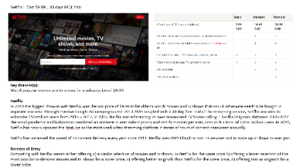
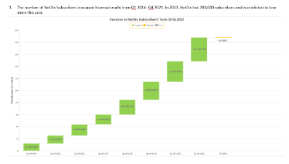

Kinoklik
Software Developer | (Montreal, Ontario) | May 2016 – Aug 2018
- Created a Netflix-like website from scratch with the CEO and a team of 2 developers.
- Coded in React, AWS and Node to produce the product ready for market launch. Delivered the product on time and in budget in 6 months.
- Went from 0 users to 12,500 in a span of 2 years At first, started at the company independently, providing exceptional results!

EDUCATION
Masters in Business Administration (MBA) – Western Governors University (2020)
Computer Science Degree - Western Governor’s University (2016);
Six Sigma Black Belt – PearsonVue (2017)
Certified Scrum Master™ - Scrum Alliance (2018)

KNOWLEDGE & EXPERIENCE
Building product roadmaps. Own story backlog. Wrote user stories. Removed roadblocks from teams. Currently work with a cross-functional teams. Able to define goals and KPIs, become an expert on customer’s needs and become an expert on the product and market trends as it pertains to the product. Use JIRA, Confluence. Able to maintain relationships with stakeholders, and with clients and customers. Able to collect feedback, conduct user interviews, and write user stories. Marketing, Marketing research

For Bottom Line Results!
Cell: 704-763-1218

Resume For: RD Global Inc

Responsibilities:
- Articulate the business value of the product features to stakeholders
- Be an agile Product Owner for our development teams and own your roadmap
- Collaborate with the sales & marketing team to develop strategy and customer-centric design in every product discussion
- Understand and articulate customer needs, partner with UX to conduct customer research, leverage internal knowledge and expertise, and prioritize requirements
- Ensure product roadmap and vision are communicated to the development team
- Works closely with the Development Team to scope/design features & functionality
- Clearly articulate and elaborate product/feature requirements to architects, designers, analysts, and developers
- Serves as both the product and subject matter expert for assigned product(s), in support of the Product Manager/Director
- Manages deadline, scope, budget, etc.
- Supports and participates in Agile process events - sprint planning, stand-ups, demos, retrospectives, etc. to help ensure team velocity and success
- Lead and influence a cross functional team to ensure the team delivers products that meet business requirements/needs and delivers business and operational value to customers

Requirements:
- Bachelor’s degree in business, computer science or related field
- Demonstrate ability to understand and discuss technical concepts, manage tradeoffs, and evaluate new ideas
- Able to work effectively with geographically dispersed remote teams
- High attention to detail including precise and effective customer communications and proven ability to manage multiple priorities simultaneously
- Understanding fundamental design principles behind a scalable application
- Expert knowledge of Agile, Scrum methodologies etc.
- Able to work with minimal supervision
- Excellent organizational, facilitation, and written/verbal communication skills
- SAAS experience is a plus

